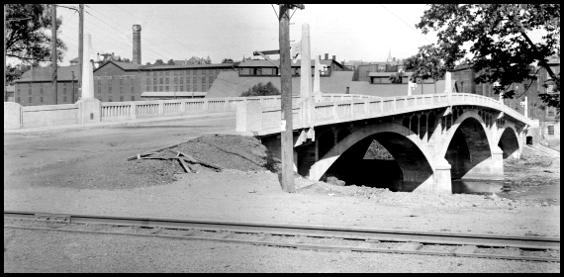
(Early 1920’s Horace Heistand photo from glass plate negative)
My Bridge Got a Hole In It & I Ain’t Crossing Here No More

With the old cement bridge connecting our towns being closed for repairs and the stories and rumors of its demise spreading, it seemed like the right time to do a brief local bridge history.
Our current cement bridge was opened in 1922. That makes it 83 years old. The TRIP report states that most bridges have a design life of 40 to 50 years. Also, 45 percent of Pennsylvania’s bridges are more than 50 years old, and 17 percent are more than 75 years old. Many people would be surprised to find out that this current day bridge is actually the fourth bridge to span the Schuylkill at this location.

The first bridge was a wooden covered bridge and opened on September 7, 1840. It was a lattice bridge built after the plan of the old Manayunk Bridge. It had three spans resting on two piers. It was one track wide, 360 foot long, and twelve foot high. It did not have a separate walkway. It had a shingled roof and the sideboards were whitewashed. This first bridge cost $7260 and was operated as a toll bridge. It lasted ten years, until September 2nd 1850, when it was washed away during a flood. A canal boat loaded with coal was swept into the river by the flood and carried downstream smashing into the Yost Grist Mill and then taking out the bridge. It is interesting to note that the tolls collected during these ten years totaled $5768, not enough to cover the cost of the bridge. The managers and stockholders held a meeting at Sam Custer’s Tavern just five days after the loss of the bridge. They voted to rebuild at once, but made a crucial mistake when they decided to supervise the work themselves. A span from the Royersford side was completed out to the first pier. Likewise a span was begun from the Spring City side. This span collapsed during construction and a few days later heavy rain saw the whole mass of debris float away. Since this intended structure was never completed, I do not consider it as bridge number two.

In February of 1851 a contract for the erection of bridge number two, another lattice bridge, was awarded to Simon Hoyer for $4200. This second bridge opened in October of 1851. It may have endured many high waters but fell victim to fire on May 4, 1884. The old Yost mill along with the bridge was completely destroyed. It is an unsolved mystery how the fire got started. Once again the bridge board had a problem to solve. They met in September of that year and approved plans for a new iron bridge to be erected. The contract was awarded to the Phoenixville Bridge Company.

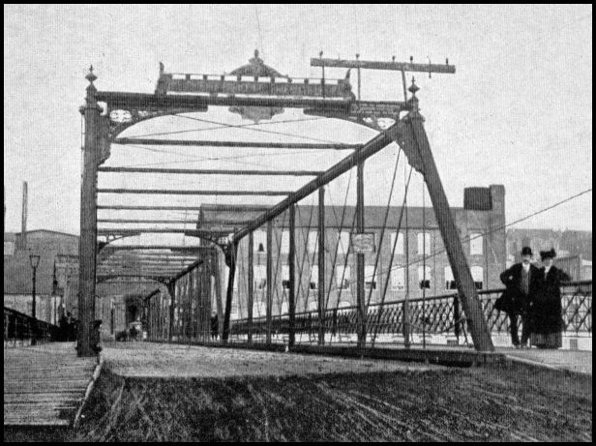
The third bridge was completed in 1887 at
a cost was $13,000. The Phoenix Bridge Company in nearby Phoenixville was known for its new-patented iron column that was used in both railroad and highway bridges. These iron columns, known for their superior strength, were manufactured by the Phoenix Iron Co. Soon thereafter, beams were being shipped up on the canal and construction of the new bridge began. In the photo to the right you can see the iron bridge with a name plaque mounted on the top. The wording on this reads “Phoenix Bridge Co”. This bridge was later purchased by the Montgomery and Chester County Commissioners for $35,000 and declared free of toll. In one of the local stories of the times a reference was made to the new “Permanent Bridge”. That permanent structure would stand for only 38 years. The bridge was a vital link between the two towns. It was just as important then as it is now, probably more so. The closest alternate bridges back then were the same ones we use today, Linfield and Black Rock. The main difference is that in 1900 you were probably walking or in a horse and buggy. In 1922 the old iron bridge was dismantled and hauled away. The most common explanation given for the demise of this bridge was rust and deterioration. It seems as if there was a minimum of maintenance during its short lifespan.

Bridge number four is our current concrete structure. This bridge is now closed for repairs.
I wonder if the lack of maintenance rings a bell, could history be repeating itself?
The cement bridge replaced the old iron bridge and was opened to the public in 1922. It is 346 feet long and has a total width of 43 feet with the actual road width being 29 feet. Closed officially for repairs on August 9, 2005, there is no doubt that the closing of the bridge will have a tremendous impact on local residents. The school bus routes for the beginning of the season must be, in some instances, totally revamped. Storeowners and businesses have been hurt; people using the bridge on the way to work must find an alternate route. This was not the case in 1922 when the contract for the new bridge was awarded. In a newspaper article, dated 4/21/1922 it stated that “The old river bridge was moved yesterday to act as a temporary bridge, what an eyesore.” The temporary span ran from aside the Royersford Spring Company to the entrance of River Park on Bridge Street in front of the existing bridge. The bid for the new cement river bridge was $84,500 and $15,892 for the Spring City canal bridge that was replaced during this same time period. Also a part of the canal bridge project was the new paving with concrete of East Bridge Street from the canal to the river bridge at a cost of $6000.
In 1979 the old concrete structure received a facelift with the installation of new sidewalks, light standards and a mesh fence. As far as I know this was mostly a cosmetic repair.

By W. Brunner & J. Burns

Spring-Ford Area Historical Society Newsletter Insert for October 2005

